PHYS 212 SPRING 2014 TEST #2 NAME ________________________________________

**Multiple choice section**: Circle the choice you believe to be the correct answer. Each question is worth 2 points unless selecting “k”.

1. A cylindrical capacitor is constructed with two conducting cylinders that are each 5.00 cm long. The inner cylinder has a radius of 0.00380 m and the outer cylinder has a radius of 0.00860 m. The space between the cylinders is filled with Neoprene which has a dielectric constant of 6.70. How much energy will be stored in this capacitor if it is charged to a potential difference of 8.40 V?
2. 3.37 x 10 – 12 J
3. 2.28 x 10 – 11 J
4. 5.71 x 10 – 10 J
5. 3.41 x 10 – 12 J
6. 1.97 x 10 – 11 J
7. 1.20 x 10 – 10 J
8. 8.05 x 10 – 10 J
9. 6.04 x 10 – 11 J
10. Zero
11. I’m getting an answer that is not one of the choices above but I’m sure that I’m doing it correctly. Please grade the work that is NEATLY presented in my green-book.
12. I don’t know how to work this problem. Please take this question to be worth 1 point rather than 2 points.
13. An electrical current of 0.625 A flows through a 240  resistor for exactly one hour. During this hour, how much electrical charge will pass through the resistor?
14. 37.5 C
15. 46.9 C
16. 36000 C
17. 150 C
18. 2250 C
19. 93.8 C
20. 18000 C
21. 5760 C
22. Zero
23. I’m getting an answer that is not one of the choices above but I’m sure that I’m doing it correctly. Please grade the work that is NEATLY presented in my green-book.
24. I don’t know how to work this problem. Please take this question to be worth 1 point rather than 2 points.

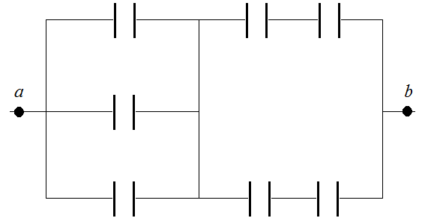

1. The diagram above shows a combination of capacitors between *a* and *b*. Each of the capacitors has a capacitance of 240 nF. What is the equivalent capacitance between *a* and *b*?
2. 180 nF
3. 411 nF
4. 1680 nF
5. 480 nF
6. 140 nF
7. 60.0 nF
8. 960 nF
9. 320 nF
10. 240 nF
11. I’m getting an answer that is not one of the choices above but I’m sure that I’m doing it correctly. Please grade the work that is NEATLY presented in my green-book.
12. I don’t know how to work this problem. Please take this question to be worth 1 point rather than 2 points.
13. A non-ideal battery has an emf of 9.43 V and an internal resistance of 3.75 . What external resistance should this battery be connected to in order for the internal resistance to dissipate energy at a rate of 28.3 milli-watts?
14. 109 
15. 91.4 
16. 121 
17. 105 
18. 97.8 
19. 115 
20. 128 
21. 88.0 
22. 82.7 
23. I’m getting an answer that is not one of the choices above but I’m sure that I’m doing it correctly. Please grade the work that is NEATLY presented in my green-book.
24. I don’t know how to work this problem. Please take this question to be worth 1 point rather than 2 points.
25. An aluminum wire has a length of 24.5 m and a diameter of 0.0128 m. Aluminum has a resistivity of 2.75 x 10 – 8 m at 20.0 °C and a temperature coefficient of resistivity of 0.00390 (°C) – 1. What will be the resistance of this wire (between its ends) at a temperature of 68.4 °C?
26. 0.00786 
27. 0.00622 
28. 0.00596 
29. 0.00561 
30. 0.00506 
31. 0.00466 
32. 0.00414 
33. 0.00388 
34. Zero
35. I’m getting an answer that is not one of the choices above but I’m sure that I’m doing it correctly. Please grade the work that is NEATLY presented in my green-book.
36. I don’t know how to work this problem. Please take this question to be worth 1 point rather than 2 points.
37. A non-ideal battery has an internal resistance of 4.60 . This battery is connected to two resistors (48.0  and 26.0 ) that are in series with one another. The 48.0  resistor dissipates energy at a rate of 0.294 J/s. What is the potential difference across the 26.0  resistor?
38. 6.15 V
39. 3.76 V
40. 2.03 V
41. 4.07 V
42. 2.81 V
43. 6.86 V
44. 3.19 V
45. 1.71 V
46. Zero
47. I’m getting an answer that is not one of the choices above but I’m sure that I’m doing it correctly. Please grade the work that is NEATLY presented in my green-book.
48. I don’t know how to work this problem. Please take this question to be worth 1 point rather than 2 points.
49. A 4.50 mF capacitor is initially charged to a potential difference of 6.00 V. The capacitor is then connected to (and allowed to discharge through) a 600  resistor. What is the potential difference across the capacitor 2.50 seconds after being connected to the resistor?
50. 3.96 V
51. 6.86 V
52. 4.28 V
53. 6.00 V
54. 3.62 V
55. 2.04 V
56. 3.41 V
57. 2.38 V
58. Zero
59. I’m getting an answer that is not one of the choices above but I’m sure that I’m doing it correctly. Please grade the work that is NEATLY presented in my green-book.
60. I don’t know how to work this problem. Please take this question to be worth 1 point rather than 2 points.

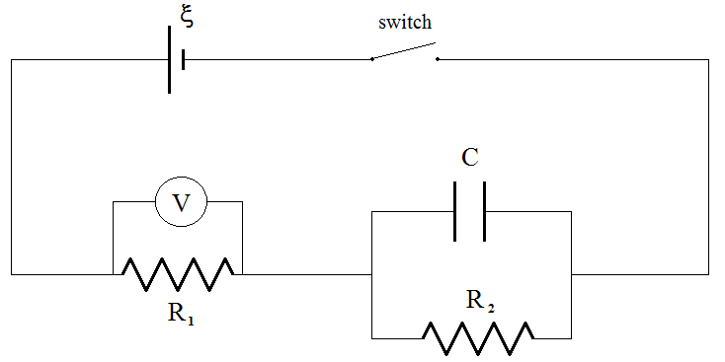

1. The circuit shown above contains an ideal battery, two resistors, an initially uncharged capacitor, a switch, and an ideal voltmeter. Which of the following sketches best represents the voltmeter reading (as a function of time) after the switch is closed?

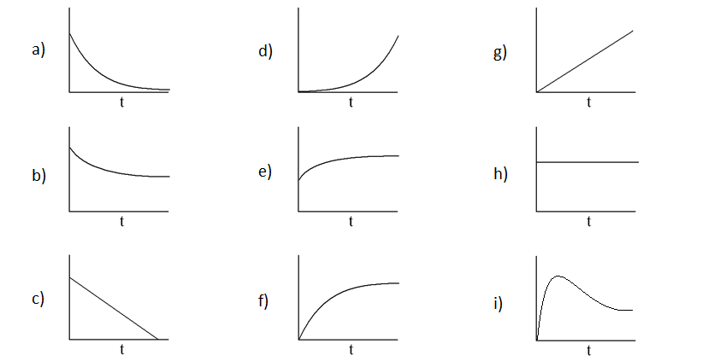

1. I’m getting an answer that is not one of the choices above but I’m sure that I’m doing it correctly. Please grade the work that is NEATLY presented in my green-book.
2. I don’t know how to work this problem. Please take this question to be worth 1 point rather than 2 points.
3. A 350  resistor and a 480  resistor are connected in parallel to each other. This combination is then connected to an 8.60 V ideal battery. At what rate will energy be dissipated by the 480  resistor?
4. 0.154 J/s
5. 0.102 J/s
6. 0.183 J/s
7. 0.211 J/s
8. 0.341 J/s
9. 0.0376 J/s
10. 0.365 J/s
11. 0.0515 J/s
12. Zero
13. I’m getting an answer that is not one of the choices above but I’m sure that I’m doing it correctly. Please grade the work that is NEATLY presented in my green-book.
14. I don’t know how to work this problem. Please take this question to be worth 1 point rather than 2 points.

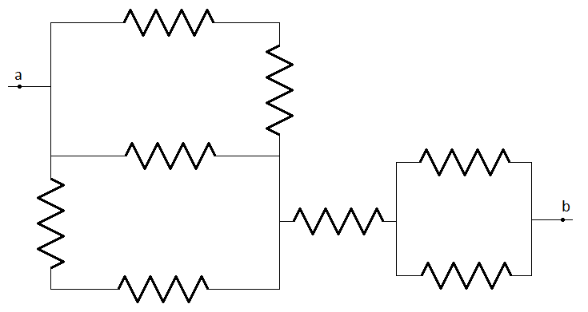

1. The diagram above shows a combination of resistors. Each of the resistors has a resistance of 240 . What is the equivalent resistance between **a** and **b**?
2. 180 
3. 411 
4. 1680 
5. 480 
6. 140 
7. 60.0 
8. 960 
9. 320 
10. 240 
11. I’m getting an answer that is not one of the choices above but I’m sure that I’m doing it correctly. Please grade the work that is NEATLY presented in my green-book.
12. I don’t know how to work this problem. Please take this question to be worth 1 point rather than 2 points.

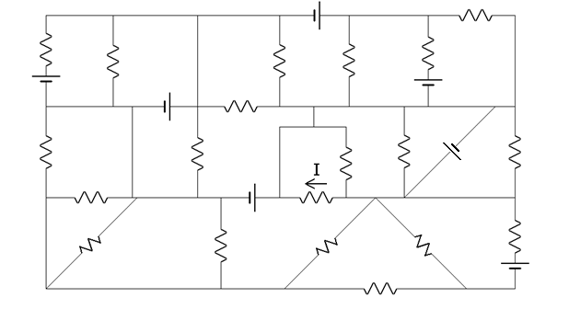

1. In the diagram above each resistor is 180  and each emf is 12.0 V. What is the value of the indicated current?
2. 0.0667 A
3. – 0.0667 A
4. 0.0333 A
5. – 0.0333 A
6. 0.0222 A
7. – 0.0222 A
8. 0.133 A
9. – 0.133 A
10. Zero
11. I’m getting an answer that is not one of the choices above but I’m sure that I’m doing it correctly. Please grade the work that is NEATLY presented in my green-book.
12. I don’t know how to work this problem. Please take this question to be worth 1 point rather than 2 points.

**Set-up problems**: You can’t select “k” on these set-up problems.

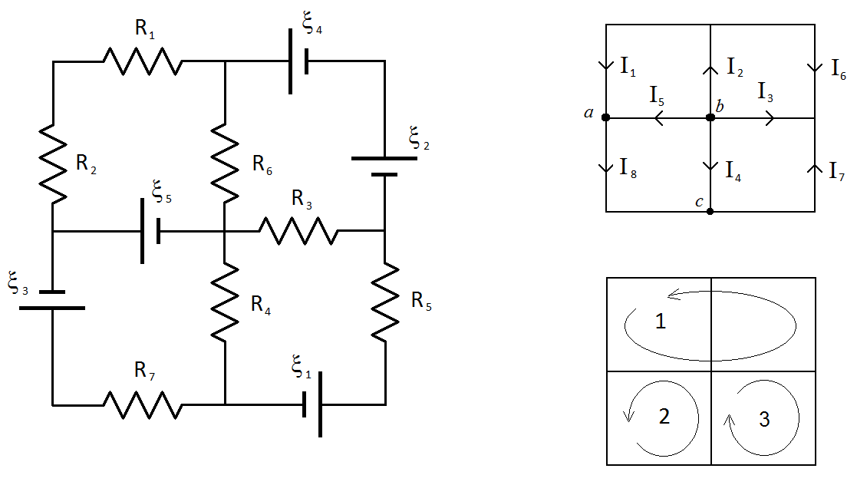

Write the equations for the following junctions and loops **as you’ve been shown/taught in PHYS 212 this semester**.

The entire equation must be correct in order to receive credit. Each of the equations is worth 1 point.

Junction rule for junction ***b***:

*I*in = *I*out

Junction rule for junction ***c***:

*I*in = *I*out

Loop rule for loop 1:

*V*rises = *V*drops

Loop rule for loop 3:

*V*rises = *V*drops